To: Vinny Saccenti

Re: Social Media Crackdown

From: Team3

Hello Mr. Saccenti,

I am very sorry to hear about the leak of the secret formula. Our team has set up firewall rules to block the addresses of Twitter, Instagram, Facebook, Reddit, and Snapchat. The employees should not be able to use these applications anymore on company infrastructure. Below are screenshots of the rules put in place as well as evidence that the sources were correctly blocked.

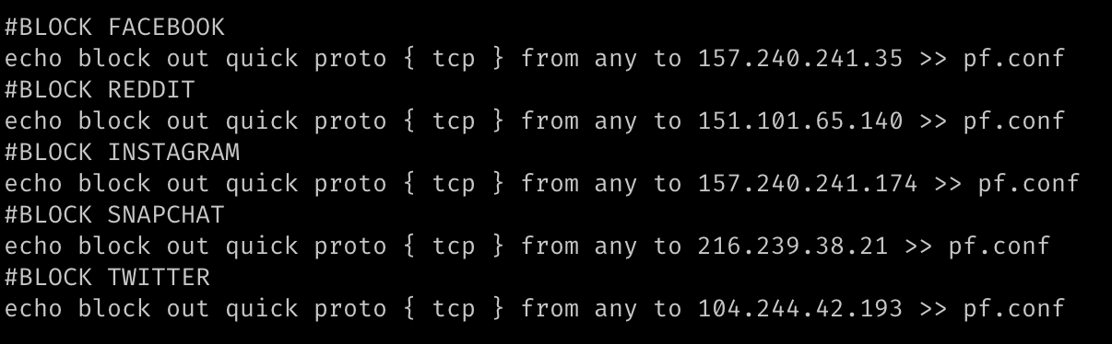

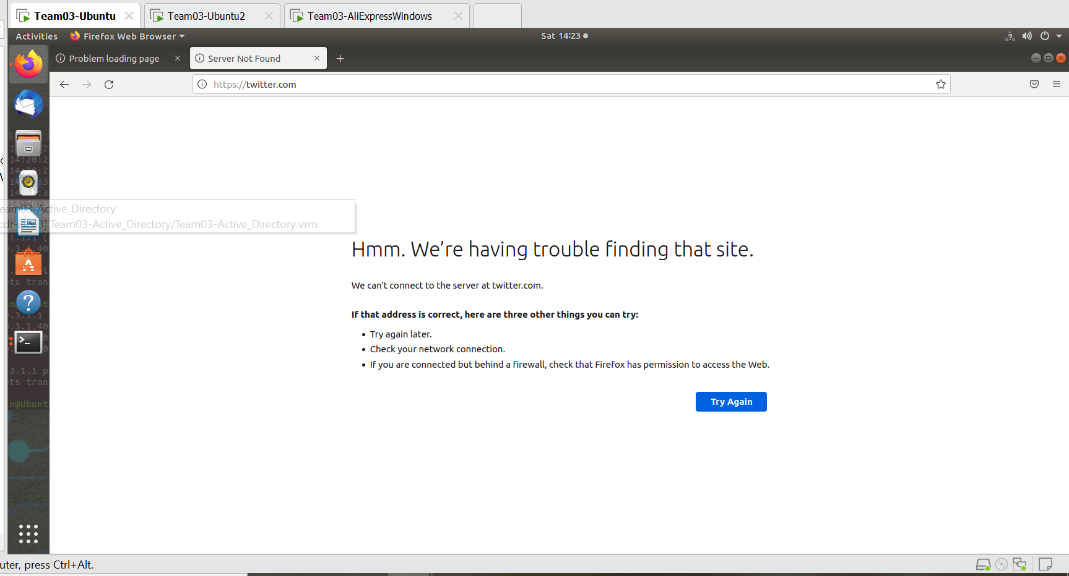

Best,

Team3